**Second Code review**

**Lam Vu, Lucas Boehm, Craig Olander, Xiang Pan**

**We have decided to use Fabric.js as the foundation of our project as well as our canvas. The drawing tool is used to connect the objects in the canvas. Craig is responsible for the file reads, in which it should read a file and then output it onto the canvas. Lam was responsible for user login, in which was successfully done so. Lucas and Xiang is in charge of the canvas (after user logs in). From our first code review, we decided to dispose the original canvas elements and use fabric.js instead since it is better designed for our use. Nothing else has been changed.**

**Lam Vu:**

**User login html:**

<!-- saved from url=(0050)http://131.183.222.38/~lvu/cset3600/userlogin.html -->

<html><head><meta http-equiv="Content-Type" content="text/html; charset=ISO-8859-1"><style type="text/css"></style></head><body><font face="verdana,arial" size="-1">

<center><table cellpadding="2" cellspacing="0" border="0" id="ap_table">

<tbody><tr><td bgcolor="blue"><table cellpadding="0" cellspacing="0" border="0" width="100%"><tbody><tr><td bgcolor="blue" align="center" style="padding:2;padding-bottom:4"><b><font size="-1" color="white" face="verdana,arial"><b>Enter your login and password</b></font></b></td></tr>

<tr><td bgcolor="white" style="padding:5"><br>

<form action="http://131.183.222.38/~lvu/cset3600/authenticate.php" method="post">

<input type="hidden" name="action" value="login">

<input type="hidden" name="hide" value="">

<center><table>

<tbody><tr><td><font face="verdana,arial" size="-1">Login:</font></td><td><input type="text" name="login"></td></tr>

<tr><td><font face="verdana,arial" size="-1">Password:</font></td><td><input type="password" name="password"></td></tr>

<tr><td><font face="verdana,arial" size="-1">&nbsp;</font></td><td><font face="verdana,arial" size="-1"><input type="submit" value="Send"></font></td></tr>

<tr><td colspan="2"><font face="verdana,arial" size="-1">&nbsp;</font></td></tr>

<tr><td colspan="2"><font face="verdana,arial" size="-1">Lost your username or password? Find it <a href="http://131.183.222.38/~lvu/cset3600/forgotpassword.html">here</a>!</font></td></tr>

</tbody></table></center>

</form>

</td></tr></tbody></table></td></tr></tbody></table>

</center></font></body></html>

**Forms:**

<!DOCTYPE html>

<html>

<body>

<form action="demo_form.asp">

Select your favorite color: <input type="color" name="favcolor"><br>

<input type="submit">

</form>

<form action="demo_form.asp">

Birthday (date and time): <input type="datetime" name="bdaytime">

<input type="submit">

</form>

<form action="demo_form.asp">

Birthday (month and year): <input type="month" name="bdaymonth">

<input type="submit">

</form>

</body>

</html>

**Forgot password:**

<font face="verdana,arial" size=-1>

<center><table cellpadding='2' cellspacing='0' border='0' id='ap_table'>

<tr><td bgcolor="blue"><table cellpadding='0' cellspacing='0' border='0' width='100%'><tr><td bgcolor="blue" align=center style="padding:2;padding-bottom:4"$

<tr><td bgcolor="white" style="padding:5"><br>

<input type="hidden" name="action" value="lost2">

<center><table>

<tr><td><font face="verdana,arial" size=-1>Email:</font></td> <td><font face="verdana,arial" size=-1><input type="text" name="email"></td>

<td><font face="verdana,arial" size=-1><input type="submit" value="Submit"></td></tr>

</table></center>

</form>

</td></tr></table></td></tr></table>

**Authenticate:**

<?php

$login_id = $_POST['group5'];

$password = $_POST['group5'];

echo "You have successfully logged in."

?>

**ID & Password:**

User name: group5

Password : group5

**Lucas Boehm:**

**Canvas to draw on:**

<!DOCTYPE html>

<html>

<head>

<meta http-equiv="content-type" content="text/html; charset=UTF-8">

<title>fabric.js freeDrawing</title>

<script type='text/javascript' src='https://ajax.googleapis.com/ajax/libs/jquery/1.7.2/jquery.min.js'></script>

<script type='text/javascript' src="https://rawgithub.com/kangax/fabric.js/master/dist/all.js"></script>

<script type='text/javascript'>

$(window).load(function(){

var canvas;

$(function () {

canvas = window._canvas = new fabric.Canvas('canvas');

canvas.backgroundColor = '#efefef';

canvas.renderAll();

document.getElementById('freedraw').addEventListener('click', function () {

canvas.isDrawingMode = !canvas.isDrawingMode;

canvas.freeDrawingBrush.width = 15;

});

document.getElementById('colorpicker').addEventListener('change', function (e) {

console.log(e.target.value);

canvas.freeDrawingBrush.color = e.target.value;

});

});

});

</script>

</head>

<body>

<canvas id="canvas" width="600" height="600" class="canvas"></canvas>

<button id="freedraw" class="btn btn-info">Enter drawing mode</button>

<input type="color" id="colorpicker" />

</body>

</html>

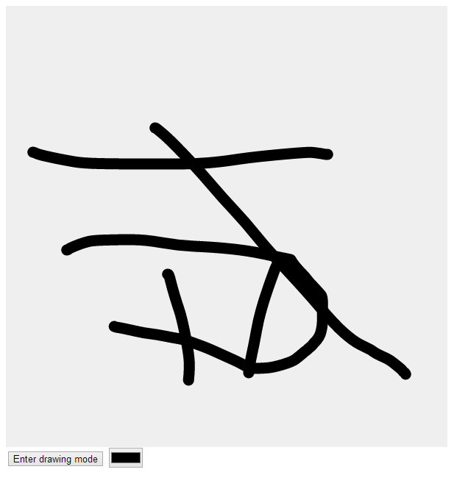

**Xiang Pan:**

**Canvas as a whole:**

<!DOCTYPE html>

<html>

<head>

<meta http-equiv="content-type" content="text/html; charset=UTF-8">

<title>Canvas</title>

<script type='text/javascript' src='jquery-1.10.1.js'></script>

<script type='text/javascript' src="http://cdnjs.cloudflare.com/ajax/libs/modernizr/2.6.2/modernizr.min.js"></script>

<script type='text/javascript' src="http://fabricjs.com/lib/fabric.js"></script>

<style type='text/css'>

#canvas-container {

position: relative;

width: 1200px;

height: 700px;

box-shadow: 0 0 5px 1px black;

margin: 5px auto;

border: 5px solid transparent;

}

#canvas-container.over {

}

#images img.img_dragging {

opacity: 0.4;

}

#saveImg {

background:yellow;

}

#imageControl {

width:800px;

height:25px;

min-height:25px;

position: relative;

display:none;

}

#canvas-container-controls {

position: relative;

width: 450px;

min-height: 50px;

border: 5px solid transparent;

}

#imageControlWrapper {

min-height:15px;

}

.imgBtn {

background:#ccc;

border:solid 1px #A8A8A8;

}

/* Prevent the text contents of draggable elements from being selectable. */

[draggable] {

-moz-user-select: none;

-khtml-user-select: none;

-webkit-user-select: none;

user-select: none;

/* Required to make elements draggable in old WebKit */

-khtml-user-drag: element;

-webkit-user-drag: element;

cursor: move;

}

#drawing-mode {

margin-bottom: 10px;

vertical-align: top;

}

#drawing-mode-options {

display: inline-block;

vertical-align: top;

margin-bottom: 10px;

margin-top: 10px;

background: #f5f2f0;

padding: 10px;

}

label {

display: inline-block; width: 130px;

}

.info {

display: inline-block;

width: 25px;

background: #ffc;

}

#bd-wrapper {

min-width: 1500px;

}

</style>

<script type='text/javascript'>

$(window).load(function(){

var canvas = new fabric.Canvas('canvas');

canvas.backgroundColor = '#ffffff';

function handleDragStart(e) {

[].forEach.call(images, function (img) {

img.classList.remove('img_dragging');

});

this.classList.add('img_dragging');

}

function handleDragOver(e) {

if (e.preventDefault) {

e.preventDefault(); // Necessary. Allows us to drop.

}

e.dataTransfer.dropEffect = 'copy';

return false;

}

function handleDragEnter(e) {

// this / e.target is the current hover target.

this.classList.add('over');

}

function handleDragLeave(e) {

this.classList.remove('over'); // this / e.target is previous target element.

}

function handleDrop(e) {

// this / e.target is current target element.

e.preventDefault();

if (e.stopPropagation) {

e.stopPropagation(); // stops the browser from redirecting.

}

var img = document.querySelector('#images img.img_dragging');

console.log('event: ', e);

var newImage = new fabric.Image(img, {

width: img.width,

height: img.height,

// Set the center of the new object based on the event coordinates relative

// to the canvas container.

left: e.layerX,

top: e.layerY

});

canvas.add(newImage);

return false;

}

function handleDragEnd(e) {

// this/e.target is the source node.

[].forEach.call(images, function (img) {

img.classList.remove('img_dragging');

});

}

var removeSelectedEl = document.getElementById('remove-selected');

removeSelectedEl.onclick = function() {

var activeObject = canvas.getActiveObject(),

activeGroup = canvas.getActiveGroup();

if (activeGroup) {

var objectsInGroup = activeGroup.getObjects();

canvas.discardActiveGroup();

objectsInGroup.forEach(function(object) {

canvas.remove(object);

});

}

else if (activeObject) {

canvas.remove(activeObject);

$("#imageControl").fadeOut('slow');

}

};

var sendBackwardsEl = document.getElementById('send-backwards');

sendBackwardsEl.onclick = function() {

var activeObject = canvas.getActiveObject();

if (activeObject) {

canvas.sendBackwards(activeObject);

}

};

var bringForwardEl = document.getElementById('bring-forward');

bringForwardEl.onclick = function() {

var activeObject = canvas.getActiveObject();

if (activeObject) {

canvas.bringForward(activeObject);

}

};

document.getElementById('saveImg').onclick = function() {

if (!fabric.Canvas.supports('toDataURL')) {

alert('This browser doesn\'t provide means to serialize canvas to an image');

}

else {

canvas.deactivateAll().renderAll();

//make into json, with a preview popup, then confirm btn to save to database

window.open(canvas.toDataURL('png'));

}

};

canvas.on('selection:cleared', function(options) {

var activeObject = canvas.getActiveObject();

if (activeObject === null) {

$("#imageControl").fadeOut('slow');

console.log('CLEARED');

}

});

canvas.on('object:selected', function(options) {

var activeObject = canvas.getActiveObject();

if (options.target && activeObject !== null) {

$("#imageControl").show('slow');

console.log('SINGLE-SELECTED');

}

});

canvas.on('selection:created', function(options) {

if (options.target) {

$("#imageControl").show('slow');

console.log('SELECTION-MULTI');

}

});

if (Modernizr.draganddrop) {

// Browser supports HTML5 DnD.

// Bind the event listeners for the image elements

var images = document.querySelectorAll('#images img');

[].forEach.call(images, function (img) {

img.addEventListener('dragstart', handleDragStart, false);

img.addEventListener('dragend', handleDragEnd, false);

});

// Bind the event listeners for the canvas

var canvasContainer = document.getElementById('canvas-container');

canvasContainer.addEventListener('dragenter', handleDragEnter, false);

canvasContainer.addEventListener('dragover', handleDragOver, false);

canvasContainer.addEventListener('dragleave', handleDragLeave, false);

canvasContainer.addEventListener('drop', handleDrop, false);

} else {

// Replace with a fallback to a library solution.

alert("This browser doesn't support the HTML5 Drag and Drop API.");

}

clearEl.onclick = function() { canvas.clear() };

});

</script>

<script type='text/javascript' src="https://rawgithub.com/kangax/fabric.js/master/dist/all.js">

$(window).load(function(){

var canvas;

$(function () {

canvas = window._canvas = new fabric.Canvas('canvas');

canvas.backgroundColor = '#efefef';

canvas.renderAll();

document.getElementById('freedraw').addEventListener('click', function () {

canvas.isDrawingMode = !canvas.isDrawingMode;

canvas.freeDrawingBrush.width = 10;

});

document.getElementById('colorpicker').addEventListener('change', function (e) {

console.log(e.target.value);

canvas.freeDrawingBrush.color = e.target.value;

});

});

});

</script>

</head>

<body>

<div id="images">

<img draggable="true" src="cmp.png"></img>

<img draggable="true" src="svr.png"></img>

</div>

<div id="canvas-container-controls">

<div id="imageControlWrapper">

<div id="imageControl">

<button class= "imgBtn" id="saveImg">Save Canvas</button>

<button class="imgBtn" id="remove-selected">Remove selected</button>

<button id="send-backwards" class="imgBtn">Send backwards</button>

<button id="bring-forward" class="imgBtn">Bring forwards</button>

</div>

</div>

<button id="freedraw" class="btn btn-info">Enter drawing mode</button>

<button id="clear-canvas" class="btn btn-info">Clear</button><br>

<div style="display: inline-block; margin-left: 10px">

<div id="drawing-mode-options">

<label for="drawing-mode-selector">Mode:</label>

<select id="drawing-mode-selector">

<option>Pencil</option>

<option>line</option>

</select><br>

<div id="canvas-container">

<canvas id="canvas" width="1200" height="600"></canvas>

</div>

</div>

</div>

</div>

</body>

</html>

